Exploratory Content Analysis:
Masculinity Influencers in Nigeria and Kenya
Gates-Funded Research Project
Discourse Analysis of Creator Content — Exploratory Phase
2026

1. Introduction
This report presents exploratory findings from a discourse analysis of content produced by six masculinity influencers in Nigeria and five in Kenya. The analysis is part of a larger Gates Foundation-funded study examining how social media content creators construct, contest, and circulate norms of masculinity in sub-Saharan African digital publics. The broader project employs both human coding across trained research teams and large language model (LLM)-assisted analysis; this document reports on the first phase, which examines raw verbatim content directly, prior to the application of structured question-by-question coding (a systematic checklist where trained coders or an AI model answers specific questions about each piece of content).
The conceptual architecture of the project draws on two foundational frameworks. Connell and Messerschmidt’s (2005) reformulation of hegemonic masculinity (the dominant cultural ideal of manhood that others are measured against) provides the primary structural lens: masculinity is not a fixed trait but a relational configuration of practice, achieved and contested in specific social and institutional contexts. The creators studied here are understood as occupants of a particular position within a gendered social field — one in which digital platforms confer reach, visibility, and norm-setting authority. Glick and Fiske’s (1996) ambivalent sexism (the combination of hostile attitudes toward women who challenge male authority and seemingly positive but controlling attitudes toward women who comply) theory provides a complementary instrument for analyzing the specific valence of gender attitudes expressed in the content, distinguishing hostile sexism (open hostility, derogation, or desire to control women) (antipathy, dominance, derogation) from benevolent sexism (seemingly positive but patronising attitudes that still cast women as weak or in need of male protection) (protective paternalism, idealized femininity, heterosexual intimacy framing). Neither framework is applied mechanically; rather, they orient analytical attention toward the ideological work that content performs.
The central research questions addressed in this report are: What discursive (relating to how language shapes social meaning and power) strategies do progressive and regressive creators deploy in constructing masculinity norms? Where do the two countries converge in their representations, and where do they diverge? What are the analytically significant themes that will require systematic attention in the human and LLM coding phases? The findings reported here are exploratory and interpretive rather than statistically representative; they are intended to generate hypotheses and sensitize the research team to the conceptual landscape of the corpus (the full body of content or text analyzed).

2. Data and Sample
The content corpus consists of 704 verbatim text snippets drawn from eleven creators across Nigeria (310 snippets) and Kenya (394 snippets). Sampling was purposive: creators were selected to achieve balance across progressive and regressive orientations, a distinction operationalized (translated into concrete, measurable categories) through a combination of platform presence, content framing, and prior researcher assessment. Within each country, creators were further sampled to represent variation in platform (video podcast, X/Twitter, stage performance) and format (monologue, interview, tweet).
Nigeria’s corpus skews regressive by count (55.8% regressive vs. 44.2% progressive), while Kenya’s is majority progressive (52.3% vs. 47.7% regressive). Platform representation also differs: Nigeria’s corpus is majority X/Twitter (63.5%), while Kenya’s is majority YouTube (65.0%), reflecting the different dominant platforms used by sampled creators in each country. These structural differences in corpus composition are noted not as deficiencies but as analytically relevant features: they shape what kinds of speech acts, rhetorical registers, and audience orientations are represented.
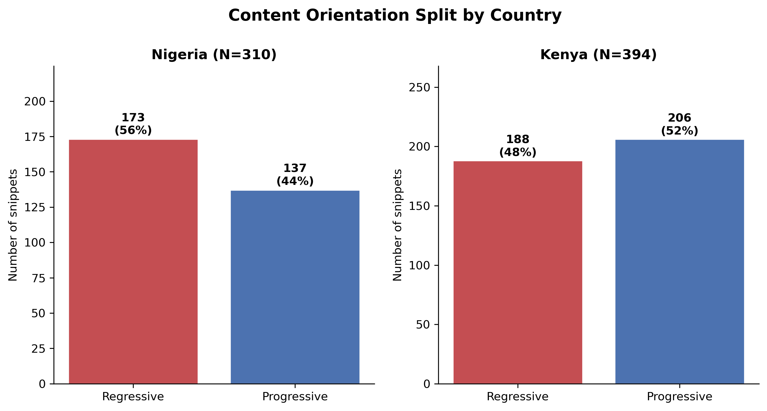
Figure 1. Content orientation split by country

Data Sources. This report uses the final complete creator-content datasets for the current project phase: Nigeria Content Analysis Final (https://docs.google.com/spreadsheets/d/1eD1VtTNuu4ZIha44W8Mu47t3KGkG8dPHufduFtpgPhQ/edit?gid=1051754090#gid=1051754090) and Kenya Content Analysis Final (https://docs.google.com/spreadsheets/d/1VE8MUfdQ9_pw8aajZsIQnmY9nUnRnwB8GCAHHGrPXBs/edit?usp=drive_link). The companion audience report uses the corresponding final audience-comment datasets. All counts reported here are based on the final complete datasets, not intermediate exports, partial samples, or stale coder files.

Table 1. Nigeria Content Corpus: Creator Overview
Creator (Code) | Platform | Format | Orientation | Snippets | % of Corpus
Banky Wellington (BNK) | YouTube | Podcast snippet | Progressive | 76 | 24.5%
Ebuka Obi-Uchendu (EBK) | YouTube | Podcast monologue | Progressive | 37 | 11.9%
Deyemi Okanlawon (DEY) | X/Twitter | Tweet | Progressive | 24 | 7.7%
Agba John Doe (AGB) | X/Twitter | Tweet | Regressive | 52 | 16.8%
Wizarab (WIZ) | X/Twitter | Tweet | Regressive | 49 | 15.8%
Shola (SHO) | X/Twitter | Tweet | Regressive | 72 | 23.2%
TOTAL |  |  | Prog: 137 / Reg: 173 | 310 | 44.2% Progressive / 55.8% Regressive
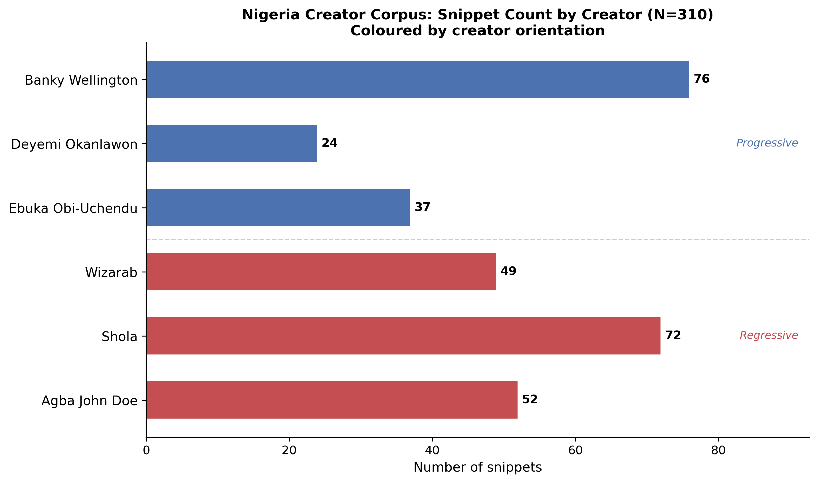
Figure 2. Nigeria creator corpus: snippet count by creator and content orientation.

Table 2. Kenya Content Corpus: Creator Overview
Creator (Code) | Platform | Format | Orientation | Snippets | % of Corpus
Onyango Otieno / Rixpoet (RIX) | YouTube | Workshop/Lecture | Progressive | 100 | 25.4%
Eddy Kimani (EDDY) | YouTube | Stage Talk/Testimony | Progressive | 65 | 16.5%
Philip Karanja (PHIL) | Podcast (CTA101) | Podcast Interview | Progressive | 41 | 10.4%
Eric/Amerix | X/Twitter | Tweet | Regressive | 97 | 24.6%
Andrew Kibe | YouTube (Jagero) | Podcast Interview | Regressive | 91 | 23.1%
TOTAL |  |  | Prog: 206 / Reg: 188 | 394 | 52.3% Progressive / 47.7% Regressive
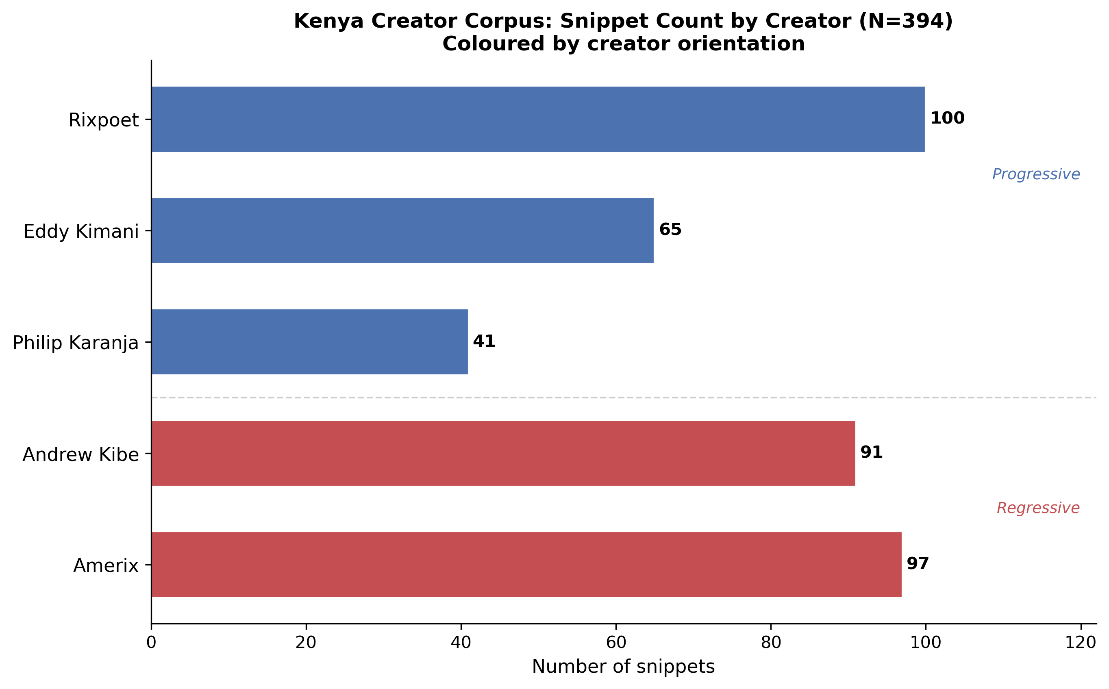
Figure 3. Kenya creator corpus: snippet count by creator and content orientation.

3. Analytical Approach
This analysis applies discourse analysis to verbatim content. Rather than beginning with a pre-specified coding scheme and fitting content into categories, this exploratory phase reads the corpus inductively, attending to the specific language, rhetorical moves, and ideological assumptions that organize creator speech. Discourse analysis in this context means attending to how language does work: how it constructs subject positions, naturalizes social arrangements, forecloses alternative framings, and interpellates (positions or recruits people into a particular social identity or viewpoint) audiences into particular stances. A tweet is not simply a data point to be coded — it is a speech act directed at a specific community, using shared registers and in-group markers, performing a social identity and making a claim on what is normal or desirable.
The decision to analyze raw text prior to structured question-by-question coding is methodologically deliberate. Structured coding instruments — however well-designed — necessarily impose analytical categories that may not map cleanly onto the emergent logic of the discourse itself. The exploratory phase reported here allows the data to surface patterns that may or may not correspond to prior theoretical expectations. Insights from this phase will inform the final coding instrument development and ground-truth the LLM coding outputs.
Analysis proceeded by reading each creator’s content as a coherent corpus, identifying recurrent themes, rhetorical patterns, and ideologically significant moves. Themes were then compared across creators within each country and across countries. Direct quotation is used extensively throughout; all quotes are verbatim and attributed by creator code.
Three complementary analytical approaches are applied across this report:
Framing analysis examines how issues are packaged and presented to audiences — for example, whether male dissatisfaction is framed as a social injustice, a self-improvement challenge, or a woman’s fault. Framing shapes which solutions seem natural and which groups are cast as responsible. This approach is widely used in computational social science to study how narratives and messages influence public attitudes (Saveleva et al., 2024).
Argument mining identifies the claims being made, the reasoning used to support them, and the patterns of justification employed by creators and audiences. Rather than simply noting that a creator says women should be submissive, argument mining asks: what evidence or logic is offered? Who is blamed? What conclusion is implied? This approach is used to understand how influencers and their audiences justify gender norms (Moens et al., 2019).
Misogyny and sexism detection identifies gender-based harmful content: language that demeans, blames, or instrumentalises women as a category. This is distinct from general hostility detection and has its own established methods and benchmark datasets in the research community (Fersini et al., 2021). In this report it is applied as an interpretive lens rather than an automated classifier — the analyst identifies and flags content that meets the criteria for hostile or benevolent sexism (see Section 3 references and Glick & Fiske, 1996).
References for this section: Saveleva et al. (2024). Framing analysis. ACL Anthology. https://aclanthology.org/2024.acl-long.822/ — Moens et al. (2019). Argument mining. Computational Linguistics, 45(4). https://aclanthology.org/J19-4006/ — Fersini et al. (2021). Misogyny/sexism detection. WOAH Workshop. https://aclanthology.org/2021.woah-1.3/

4. Nigeria Content Findings

4.1 Overview
Nigeria’s 310 content snippets span six creators whose outputs differ markedly in register, platform, and ideological orientation. The progressive creators — Banky Wellington (76 snippets, YouTube podcast), Deyemi Okanlawon (24 snippets, X/Twitter), and Ebuka Obi-Uchendu (37 snippets, YouTube podcast) — collectively produce a discourse of reflexive masculinity: a mode of speaking about gender that acknowledges the costs of normative (describing or reinforcing what is considered standard or expected) expectations, entertains emotional complexity, and occasionally solicits vulnerability. The regressive creators — Shola (72 snippets), Wizarab (49 snippets), and Agba John Doe (52 snippets), all on X/Twitter — produce a discourse of strategic masculinity: a mode of speaking that treats gender relations as a competitive arena governed by legible rules, in which men who understand those rules can optimize their position.
Despite their opposing ideological orientations, all six creators operate within a shared cultural field in which the question of what masculinity should be is experienced as urgent, contested, and consequential. The fact that progressive and regressive content addresses overlapping concerns — provision, emotional expression, relationship management, fatherhood — suggests that Nigerian digital masculinity discourse is organized around a common set of pressure points, with creators staking out different positions in response to the same underlying anxieties.

4.2 Progressive Discourse: Redefining Nigerian Masculinity

Banky Wellington (BNK): Interrogating the Provider Script
Banky Wellington’s podcast content constitutes the most sustained engagement with the emotional and social costs of hegemonic masculinity in the Nigerian corpus. Wellington is a public figure — a musician, politician, and Christian activist — and his MENtality podcast operates as a deliberate effort to create a space in which men can discuss what they do not typically discuss. The recurring preoccupation of his content is the provider burden: the cultural equation of masculinity with financial provision and the specific harms this equation inflicts.
“For me, the biggest pressure is internal. But it’s influenced by a mixing, fusion of all of these factors.” — BNK
Wellington identifies internal pressure — a man’s own self-expectation — as the proximate mechanism, while refusing to assign sole causality to any one external source (family, spouse, society). This is a sophisticated move: it acknowledges the reality of the experience while resisting a scapegoating logic that would simply blame women or tradition. The podcast goes further, narrating the emotional foreclosure that the provider burden produces:
“In Nigeria, you lose someone, then you have to man up. You have to get money for the burial. Then after you pay for the burial, you have to get back to working. Sometimes, there’s no room for you to really sit down and cry.” — BNK
This passage maps what Connell (1995) would recognize as the cost structure of hegemonic masculinity: the position of social authority and responsibility that dominant masculinity confers is simultaneously a structure of emotional dispossession. The Nigerian man who “mans up” for a funeral is performing a service to his community at the price of his own grief.
Wellington’s treatment of financial transparency in marriage is equally striking. Discussing his own relationship, he describes a model of radical financial partnership:
“I tell my wife everything I make. She knows how much it is. She doesn’t go and misbehave. This is exactly what we are worth.” — BNK
“She has my bank password. She has the code of the account.” — BNK
The framing of “our money” and collective ownership directly challenges the normative model in which men control financial resources as both a prerogative and a symbol of authority. Wellington also engages scripture critically, noting that the passage from 1 Timothy 5:8 (“worse than an infidel”) is often weaponized to pressure men as providers — and interrogating what such interpretation requires of actual human beings. This represents a theologically-literate progressive masculinity discourse that does not abandon religious frameworks but reads them more capaciously.

Deyemi Okanlawon (DEY): Male Voice and Epistemic Legitimacy
Okanlawon’s Twitter output is more episodic than Wellington’s podcast monologues, but it advances a consistent argument: men have the right to articulate and revise their own truths, and this right is not contingent on conformity to any stable masculine script.
“As with women, it’s perfectly fine for and the right of men to also speak out and to speak their ‘truth’. Also it’s even ok for the ‘truth’ to evolve/change over time.” — DEY
The scare-quoting of “truth” does important rhetorical work here: it acknowledges that men’s expressed experiences are perspectival rather than universal, while simultaneously asserting those experiences’ legitimacy. This is a notably sophisticated position in a discourse environment (X/Twitter) that frequently rewards confident assertion over epistemic (relating to knowledge and how claims are justified) humility.
Okanlawon also addresses the provider script, but with a touch of humor that distinguishes his approach from Wellington’s more earnest register. In a widely discussed tweet, he describes repaying a loan from his wife — inverting the standard provision hierarchy and then narrating his impulse to celebrate her with the repaid funds. The humor is strategic: it makes visible an arrangement (wife as financial resource) that is likely common but rarely acknowledged, and it refuses the shame that normative masculinity would attach to it.
“If you’re not yet financially buoyant perhaps it is wise take a break from ‘serious’ relationship and focus on building yourself... this message from the federal association of common sense is for men & women” — DEY
This post, with its mock-institutional “federal association of common sense” framing, applies what appears to be relationship advice even-handedly across genders. This symmetry is ideologically significant: it decouples self-development from a specifically masculine provider imperative.

Ebuka Obi-Uchendu (EBK): Fatherhood and the Question of Respect
As the MENtality podcast’s primary host, Ebuka Obi-Uchendu contributes 37 snippets that engage most centrally with fatherhood, discipline, and the question of whether change in parenting norms entails a loss of legitimate authority. Obi-Uchendu is candid about his own uncertainty:
“I don’t know that I’m a gentle parent. My wife doesn’t think I am. And I do a lot of carrots and stick. I’ve never hit my kids, but I do the carrots and stick figuratively.” — EBK
This honesty about the gap between aspiration and practice is a characteristic feature of progressive masculinity discourse at its most self-aware. Obi-Uchendu is not claiming to have arrived at a reformed masculinity; he is actively working through what it means to parent differently from how he was parented, while retaining authority. His question — “What is respect and what is fear?” — is one of the most conceptually precise formulations in the corpus:
“What is respect and what is fear? I guess is where the line is drawn. As a father, most fathers were feared, but you still want to keep the respect.” — EBK
Obi-Uchendu also engages the domestic labor question directly, asking whether a wife’s expectation that her husband help with household tasks erodes the gendered division of labor. His willingness to voice this question without definitively resolving it is itself analytically important: it suggests that the progressive masculinity podcast space functions as a site for thinking through, rather than arriving at, positions.

4.3 Regressive Discourse: Reinscribing Hierarchical Masculinity

Shola (SHO): Sexual Marketplace Logic
Shola’s 72 tweets constitute the most internally consistent elaboration of sexual marketplace ideology in the Nigerian corpus. The core premise is that heterosexual relations are governed by market dynamics — supply, demand, value, strategy — and that men who understand these dynamics are empowered to optimize their position, while men who do not are deluded and vulnerable. Women appear in this framework primarily as assets to be assessed or avoided.
“Nice guys are just horny guys without options who have a lot of time (close to jobless) and lack self respect.” — SHO
This formulation accomplishes several ideological moves simultaneously: it pathologizes male emotional availability (“horny”), links it to economic precarity (“close to jobless”), and frames the result as a failure of self-respect. The implication is that genuine male self-respect requires cultivated indifference to romantic outcomes. This is a textbook illustration of what Glick and Fiske (1996) would classify as hostile sexism operating through male endorsement: the woman-derogating content is embedded in ostensibly male self-improvement discourse.
“Your prime race begins in your 30s, men age like wine, so there’s really no reason to rush.” — SHO
The “men age like wine” trope, ubiquitous in the Nigerian manosphere (the loosely connected online ecosystem of content creators, forums, and communities focused on male identity, often with anti-feminist leanings) content, performs a temporal reorientation of male value. It positions the sexual marketplace as one in which male value is durably appreciating rather than time-bounded, in explicit contrast to a (unstated but implied) narrative about female value declining with age. This asymmetric aging logic is a structural feature of hypergamy discourse.
Shola’s engagement with women’s self-presentation is particularly revealing of the hostile sexism dynamic:
“Every woman claims not to wear revealing clothes for men, but to feel good about themselves. Until a friend of hers visits her matrimonial home dressed to feel good about herself as well and all of a sudden she’d claim she wants to steal her man.” — SHO
The internal contradiction Shola projects onto women — claiming agency over dress while experiencing jealousy at others’ dress — is a well-documented hostile sexism move: it doubts women’s stated motivations and constructs them as fundamentally competitive, deceptive, and incapable of the solidarity they claim.

Wizarab (WIZ): Disposal Logic and Emotional Detachment
Where Shola builds an ideological system, Wizarab traffics in imperatives. His content is characterized by short, directive statements that tell men what to do with women who do not perform in ways the creator deems appropriate. The foundational move is the construction of women as inherently replaceable:
“Every whore has their favourite client. You are hers. You want to save her. Who told you she needs saving?” — WIZ
“Hypergamy. You’re not her favourite option. Throw her away and stop giving her attention. BLOCK her.” — WIZ
The term “throw her away” is not incidental — it is definitionally objectifying. The woman is framed as a thing that can be discarded once its utility is exhausted. Glick and Fiske’s hostile sexism typology identifies this as dominative hostile sexism: the assertion of male dominance through control over access to female presence. The imperative to “BLOCK” is the digital-age operationalization of this logic.
Wizarab’s content also enforces a surveillance of women’s digital self-presentation:
“Why should any sensible guy be interested in a lady twerking for the public on social media?” — WIZ
The question form is rhetorical — the answer is presupposed to be “no sensible guy should.” This positions male interest in publicly expressive women as an index of male irrationality, inverting the locus of judgment from women’s behavior to men’s response. The practical implication is the same: women who engage in public self-expression are disqualified from male serious interest. This is a digital variant of the respectability/availability binary that structures much gender ideology in sub-Saharan African contexts.

Agba John Doe (AGB): Moral Taxonomy and Female Disqualification
Agba John Doe’s content adds a moral-taxonomic dimension to the regressive cluster. Where Shola provides strategic advice and Wizarab issues imperatives, Agba adjudicates: his tweets construct explicit categories of women who are or are not deserving of male recognition. The criteria are rooted in a conservative understanding of female sexual propriety:
“All those women that sexualise themselves publicly, are bad women. They don’t deserve to get married, neither do they deserve to be mothers.” — AGB
This is among the most direct expressions of hostile sexism in the entire corpus: a categorical moral disqualification from the relational roles (wife, mother) that the same ideological framework positions as women’s primary social function. The logic is internally coherent but structurally brutal — women who fail the propriety test are expelled from the domain of legitimate femininity.
Agba’s content also reveals a distinctive community-building dimension. His followers identify as “Agbafians,” and his content deploys recurring signature markers that function as in-group shibboleths. This transformation of regressive ideology into community identity is significant for the broader project: it suggests that the normalization of hostile gender ideology is not simply a matter of individual exposure but of collective identity formation. The comment section is not just a reception site but a community forum.
At the same time, Agba’s content is not uniformly hostile. He occasionally acknowledges male fallibility:
“I was naive and it took years before I realised my mistake. That’s growth.” — AGB
This admission of personal error — however brief — complicates the purely ideological reading. It suggests that even strongly regressive creators maintain some rhetorical foothold in the discourse of personal growth and self-reflection that characterizes digital masculinity content broadly.

4.4 Cross-Cutting Themes in Nigerian Content
Several themes cut across the progressive/regressive divide in Nigeria’s corpus, revealing the shared conceptual terrain on which different masculinity ideologies are contested.
The provider burden is one of the most prominent cross-cutting themes in Nigeria’s corpus, especially in progressive content from Wellington and Okanlawon, both of whom interrogate the cultural equation of manhood with financial provision and show its emotional costs. In regressive Nigerian content, this concern appears less as emotional burden and more through sexual-marketplace, status, and relationship-control logics — a shift in register that is analytically significant. The provider norm is thus present across both orientations, but it does different ideological work in each.
Emotional expression and its regulation also crosses the progressive/regressive divide, though in radically different directions. Progressive creators construct a counter-normative space in which men’s emotional lives are legitimate subjects for public discourse — “These are the things that boys don’t talk about. Guys don’t say these things. But we know it” (BNK). Regressive creators do not argue against this framing directly; rather, they construct emotional availability as a strategic liability, a vulnerability that positions men unfavorably in the sexual marketplace. The same underlying norm — men don’t talk about feelings — is thus engaged from both sides, without ever being fully destabilized.
Platform affordances shape the form, if not the substance, of these discourses. X/Twitter content, which constitutes the entirety of the regressive creators’ corpus in Nigeria, rewards brevity, conviction, and shareability: the tweet as assertion, the retweet as endorsement. YouTube podcast content rewards elaboration, narrative, and dialogue: the monologue as reflection, the conversation as shared exploration. These formal differences may partially explain why regressive content tends toward imperatives and categorical claims, while progressive content tends toward questions and provisionally held positions.

5. Kenya Content Findings

5.1 Overview
Kenya’s 394 content snippets span five creators whose work covers an unusually wide range of platform, format, and topical emphasis. The progressive creators — Onyango Otieno/Rixpoet (100 snippets, YouTube workshop), Eddy Kimani (65 snippets, YouTube stage talk), and Philip Karanja (41 snippets, podcast interview) — together produce what is arguably the most analytically rich progressive masculinity discourse in the combined corpus. Their content engages trauma, mental health, paternal responsibility, and structural gender violence at a depth that is less visible in the sampled Nigerian progressive content reviewed here. The regressive creators — Eric/Amerix (97 snippets, X/Twitter) and Andrew Kibe (91 snippets, YouTube) — produce content that is, in some respects, more ideologically extreme than the Nigerian regressive cluster, deploying explicit hierarchical theology, evolutionary psychology tropes, and occasional reproductive-worth or fitness-based framing.
Kenya’s corpus is also distinctive in its majority-progressive composition (52.3%), which creates a different analytical environment than Nigeria’s regressive-majority corpus. This is not simply a sampling artifact — it reflects the purposive inclusion of creators (particularly Rixpoet and Philip Karanja) who operate in explicitly activist or therapeutic spaces, where the primary audience is men seeking something different from hegemonic masculinity norms.

5.2 Progressive Discourse: Trauma, Testimony, and Feminist-Aligned Advocacy

Onyango Otieno / Rixpoet (RIX): Therapeutic Masculinity and Structural Explanation
Rixpoet’s 100 snippets, drawn from a Men’s Mental Health Workshop, constitute the most explicitly therapeutic body of content in the corpus. Rixpoet is a spoken-word poet and men’s mental health advocate, and his workshop delivery integrates personal narrative, psychoeducational explanation, and collective processing in ways that distinguish it sharply from both the podcast conversation format of the Nigerian progressive creators and the stage-performance format of Eddy Kimani.
A key analytical move in Rixpoet’s content is the denationalization of men’s silence. He explicitly rejects the framing of African or Black male emotional unavailability as culturally specific:
“Our assumption often is to a black man is new it’s new to us an African man is new but you will be very surprised to know it’s actually men on a global fear — it’s men on a global sphere — we fear talking, we don’t know how to talk, it’s not just us.” — RIX
This move is ideologically significant. By locating men’s emotional reticence as a global phenomenon rather than an African cultural trait, Rixpoet refuses the exceptionalist narrative that positions African masculinity as a special problem requiring special intervention. The implication is that the forces producing male silence are structural and gendered, not cultural and particular — a framing that opens space for solidarity across contexts rather than pathologizing any specific community.
Rixpoet’s content also offers one of the corpus’s most sophisticated accounts of the relationship between chronic stress and men’s violence:
“When you are in traumatic situations or traumatic situations for a long time it becomes chronic... it means you don’t often think well or think rationally, you can do things or say things that you regret or you want to be violent.” — RIX
“You can’t process emotions properly and you can’t think rational[ly] because your body is really just trying to keep you alive because you are sensing danger too often.” — RIX
This neurobiological account of how chronic stress produces dysregulated behavior — including violence — is not prominent in the other sampled creator content reviewed here. It represents an attempt to explain rather than simply condemn men’s harmful behavior, locating the cause not in male nature or individual pathology but in conditions of sustained insecurity. This framing is compatible with feminist structural analysis while remaining addressed to men as its primary audience.

Eddy Kimani (EDDY): Radical Vulnerability and the Performance of Failure
Eddy Kimani’s 65 snippets from his Engage Kenya stage talk constitute a performance of radical public vulnerability that is, by any measure, unusual in the space of men’s public discourse. Kimani narrates his own financial failure, eviction, return to his parents’ home, and admission of defeat as an act of witness — not as a narrative of redemption to be resolved, but as evidence that failure is constitutive of the male experience and therefore not shameful.
“With no proper income coming through, I was kicked out of my rented house twice and got auctioned once... At 39 years of age, I went back home, knocked on the door, and I told my mom, ‘I failed.’ It was extremely painful.” — EDDY
The specificity of this account — twice evicted, once auctioned, at 39, knocking on the door — is rhetorically strategic. It refuses the generalities of self-help discourse and anchors vulnerability in concrete, dateable, locatable humiliation. The audience cannot dismiss this as abstract encouragement; it is testimony, and it claims the authority of experience.
Kimani’s engagement with fatherhood is equally direct:
“Get close to your children. You don’t have to feel strong and courageous to do this. Children need their fathers regardless what dad is going through inside.” — EDDY
The explicit decoupling of emotional presence from emotional competence — “you don’t have to feel strong” — challenges the hegemonic script in which fathers are required to project stability in order to parent. Kimani insists that proximity, not performance, is what children require. This formulation is practically significant in a context where men’s emotional guardedness is often rationalized as protective — as something that children benefit from.
“Being perfect is a fairy tale. Failure, scarcity, and shortcomings are all part of being a man, a father, a husband. Openness, honesty, communication are key to your relationship with your partners.” — EDDY
This is among the clearest articulations of a therapeutic masculinity counter-norm in the entire corpus: an explicit rejection of perfectionism as a masculine standard, replaced by an ethic of communicative openness. The pairing of “failure, scarcity, shortcomings” with “openness, honesty, communication” as its appropriate response reframes vulnerability as a relational resource rather than a personal deficit.

Philip Karanja (PHIL): Structural Violence and Paternal Awakening
Philip Karanja’s 41 podcast snippets occupy a distinctive space in the progressive corpus: they represent a man working through a civic and ethical awakening specifically in response to structural violence against women. Karanja’s catalyst is the femicide crisis — the documented pattern of intimate partner and family violence against women in Kenya — and his response is to trace a chain of causality from personal complacency to structural complicity.
“It was a moment that plunged me into a rabbit hole. The haunting realization of a world where the violence against women has become an unsettling norm. I have lived a sheltered life. Believing my daughter was safe. But those beliefs crumbled.” — PHIL
Karanja’s framing begins with the particular — a father’s fear for a daughter — and moves outward to the structural:
“Over 51,000 women are killed every year by an intimate partner, or family member. That’s about 140 women in a day. I quickly realised that Femicide is at the end of the long chain of SGBV.” — PHIL
The invocation of a specific statistic — 51,000 annual deaths, 140 per day — in what is ostensibly a personal-testimony podcast is notable. It signals a kind of masculinity discourse that is willing to engage with feminist epidemiological data as part of men’s own reckoning with the world. Karanja’s content is not addressed to men’s self-improvement in isolation from the conditions of women’s lives; it asks men to develop consciousness of those conditions as a prerequisite for their own transformation. This is the closest any creator in the corpus comes to explicitly feminist-aligned masculinity discourse.

5.3 Regressive Discourse: Territorial Masculinity and Female Subordination

Eric/Amerix: Hierarchical Theology and the Territorial Self
Amerix’s 97 X/Twitter snippets constitute the most systematically developed regressive ideology in the corpus. Where Nigeria’s regressive creators offer tactical advice and moral taxonomy, Amerix builds an ontological (relating to fundamental claims about the nature of reality or identity) framework: a complete account of what men and women fundamentally are, what they are for, and how they should relate. This framework draws on evolutionary psychology, a hierarchical theology, and a disciplinary masculinity ethic that valorizes stoicism, sovereignty, and the refusal of emotional reciprocity.
The foundational claim of Amerix’s framework is the denial of female romantic love:
“Women can’t love a man. It is a lie. It is an illusion. It is a fleeting imagination. Women only adore, respect and submit. It is only a man who loves a woman. UNLEARN! #ManDay” — Amerix
This is a paradigmatic instance of hostile sexism operating through a redefinition of emotional reality. By declaring women constitutionally incapable of love, Amerix forecloses the possibility of reciprocal intimacy while simultaneously positioning men as the uniquely loving party — a paradoxical combination of derogation and self-aggrandizement. The hashtag “#ManDay” situates the claim within a specifically masculinist community formation.
The territorial metaphor structures Amerix’s account of male sexuality:
“Men, A man doesn’t cheat, He expands his territory. A man is territorial. It is women who cheat because they don’t own territories.” — Amerix
The move here is a definitional one: by renaming male infidelity as territorial expansion, Amerix neutralizes the moral charge that the term “cheating” carries and relocates the concept of infidelity onto women, for whom it remains a genuine moral failure (because they “don’t own territories”). This asymmetric moral accounting is a structural feature of hostile sexism.
Amerix’s content also deploys a hierarchical theology that naturalizes gendered domination:
“There are these special breeds of soy men who cook, wash utensils and clothes while their wives are there. Are you a fool or something? That is not love. That is stupidity.” — Amerix
“Your wife is NOT your partner. There is no partnership in a relationship.” — Amerix
The rejection of domestic labor participation as incompatible with love — not merely with masculine dignity, but with the very concept of love — is an especially striking formulation. It deploys the idiom of love (presumably valued by the audience) against the practices of egalitarian partnership. And the categorical denial of marital partnership (“there is no partnership”) is the theological floor of Amerix’s system: hierarchy, not mutuality, is the correct form of intimate relationship.

Andrew Kibe: Power, Contempt, and the Unspeakable
Andrew Kibe’s 91 podcast interview snippets are the most rhetorically extreme content in the corpus. Where Amerix builds a system, Kibe performs contempt — a theatrical masculinity that positions women as collectively incompetent, men as the real agents of civilization, and vulnerability as an unaffordable luxury.
“You see women don’t see men the way men think women see men. Women they see power or puny. That’s all they see.” — Kibe
“Men who make decisions don’t have time to listen to women. What is a woman telling you? Women are for good times.” — Kibe
The reduction of women to a binary (power/puny) and a function (good times) are exemplary instances of objectifying hostile sexism. But Kibe’s content goes further than any other creator in the corpus by touching on what might be described as civilizational contempt:
“This world is run by men... [women CEO jobs] are jobs we give them.” — Kibe
The framing of women’s professional advancement as male gift — as something granted rather than achieved — is a particularly aggressive form of paternalistic (treating people as if they need to be managed or protected, rather than making their own decisions) hostile sexism. It simultaneously denies women’s agency and maintains a posture of benevolent condescension. Kibe also deploys reproductive-worth and fitness language in at least one snippet — suggesting that certain people should not reproduce — which warrants close attention and direct evidence citation in subsequent coding phases.
Kibe’s content on relationship control is equally stark:
“If she ever does that shit again, you’re out. Nobody tells me what to do. Are we together, woman? If there are plans, those plans are going to be made by me.” — Kibe
This is unambiguous intimate partner control ideology: the explicit assertion of unilateral decision-making authority within a relationship and the threat of abandonment as a sanction for non-compliance. In the context of a country with documented high rates of intimate partner violence, this content is not merely ideologically concerning but potentially materially harmful.

5.4 Cross-Cutting Themes in Kenyan Content
Kenya’s cross-cutting themes differ from Nigeria’s in both substance and intensity. The most distinctive feature of the Kenyan corpus is the centrality of trauma: both as a subject of progressive discourse (Rixpoet, Kimani) and as an implicit subtext of regressive discourse (Amerix’s insistence on emotional suppression as discipline; Kibe’s theatrical contempt as performed invulnerability).
The structural framing of gender violence is much more explicit in Kenya’s corpus than in Nigeria’s corpus, and appears across multiple progressive Kenyan creators. Philip Karanja names femicide as a systemic pattern; Rixpoet connects men’s violence to chronic stress and dysregulated nervous systems; Eddy Kimani insists that children need fathers who are present even in the midst of their own suffering. Together, these creators construct a progressive masculinity discourse that is not only about what men should feel or how they should relate to women, but about the material conditions — economic precarity, social isolation, patriarchal violence — that shape men’s possibilities.
The regressive creators in Kenya are, by contrast, more elaborated in this sampled set in terms of ideological scope, though this may partly reflect platform and creator-selection differences. Amerix builds a complete ontological system; Kibe performs civilizational contempt. Both deploy discourse that extends beyond personal advice into claims about the nature of men, women, society, and civilization. This ambition may reflect platform dynamics — Kibe’s podcast format affords extended elaboration — or it may reflect a Kenyan discursive context in which the stakes of gender ideological contest feel especially high.

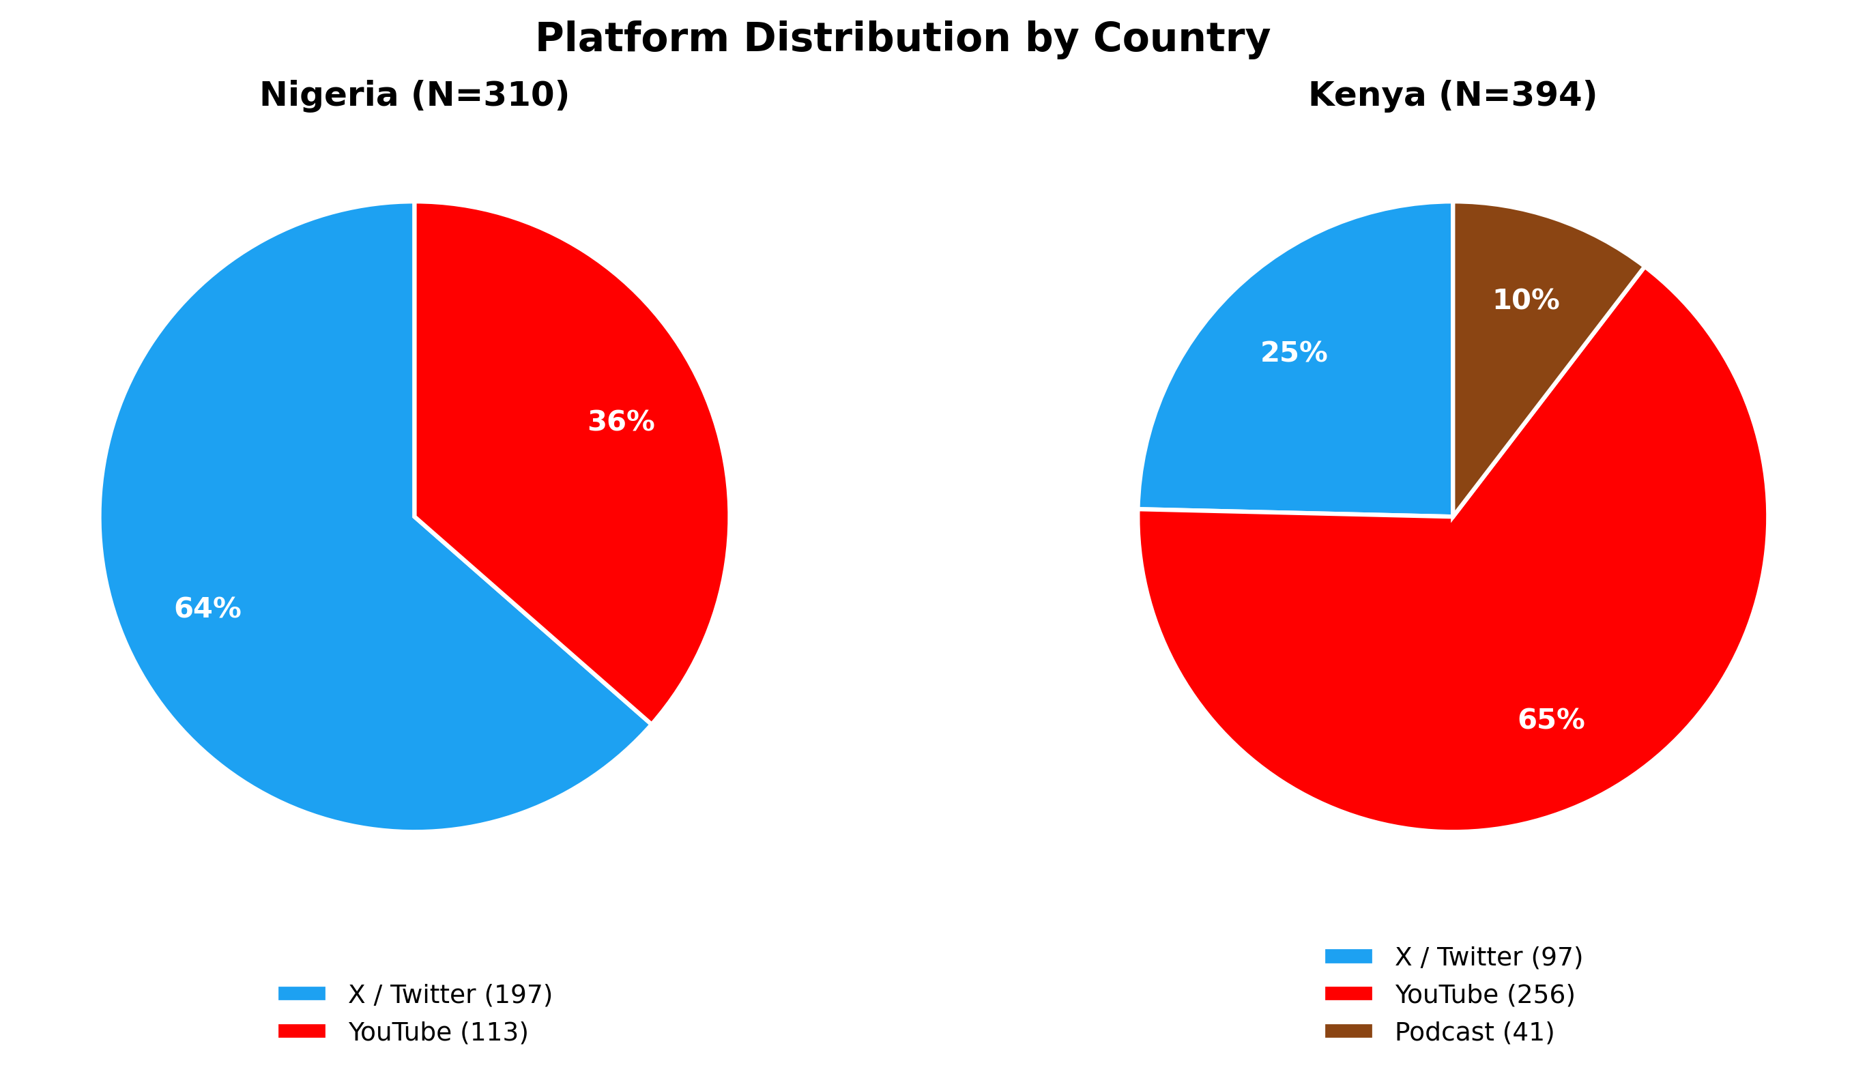
Figure 4. Platform distribution by country — Nigeria (left) and Kenya (right).

6. Cross-National Comparative Analysis
Comparing the Nigerian and Kenyan corpora reveals both structural similarities and meaningful divergences in the landscape of digital masculinity discourse.
The most important point of convergence is the centrality of the provider-as-masculine-core equation in both countries. Across progressive and regressive creators in Nigeria and Kenya alike, men’s financial capacity is treated as the primary axis of masculine legitimacy. This suggests that, whatever regional variation exists in other dimensions of masculinity ideology, the economic structuring of gender identity is a robust cross-national feature of sub-Saharan African manfluencer discourse. The significant divergence is in how creators respond to this equation: progressive creators across both countries work to denaturalize, question, or reframe it; regressive creators across both countries reinforce and operationalize it.
The most important point of divergence is in the depth and explicitness of trauma discourse. Kenya’s progressive creators — particularly Rixpoet and Kimani — engage men’s psychological injury, the intergenerational transmission of violence, and the physiological effects of chronic stress in ways that are less visible in the sampled Nigerian corpus reviewed here. This difference may reflect the specific professional and activist contexts of Rixpoet and Karanja (men’s mental health workshop, civic advocacy), but it may also reflect a broader discursive difference in how trauma is available as a legitimate public language in each country’s digital space.
A second divergence concerns the framing of structural gender violence. Philip Karanja’s engagement with femicide statistics, the naming of SGBV as a systemic phenomenon, and the positioning of men’s individual transformation as connected to (rather than independent of) women’s safety — these are less visible in the sampled Nigerian progressive content reviewed here. Nigerian progressive creators interrogate the costs of hegemonic masculinity for men; Kenyan progressive creators additionally interrogate the costs of hegemonic masculinity for women. This is a substantive difference in the scope and political valence of what counts as progressive masculinity discourse.
On the regressive side, the Kenyan creators appear more ideologically systematic in the sampled content, though this may partly reflect platform and creator-selection differences. Amerix’s ontological framework — building from a denial of female love to a hierarchical theology to a disciplinary masculinity ethic — is the most elaborated regressive ideology in the corpus. Kibe’s contemptuous register extends further toward explicit intimate partner control logic than any Nigerian creator. The Nigerian regressive creators offer tactical advice and moral taxonomy; the Kenyan regressive creators offer worldviews.
The platform composition difference between countries — Nigeria majority Twitter, Kenya majority YouTube — may partially explain these substantive differences. Twitter’s format rewards compression and assertion; YouTube’s format rewards elaboration and narrative. The regressive Nigerian creators are working within Twitter’s constraints even when they want to build systems. The regressive Kenyan creators, with Kibe’s podcast, have the format to elaborate their ideology at length. This is an important analytical caveat: observed differences in ideological depth may be partly artifactual.
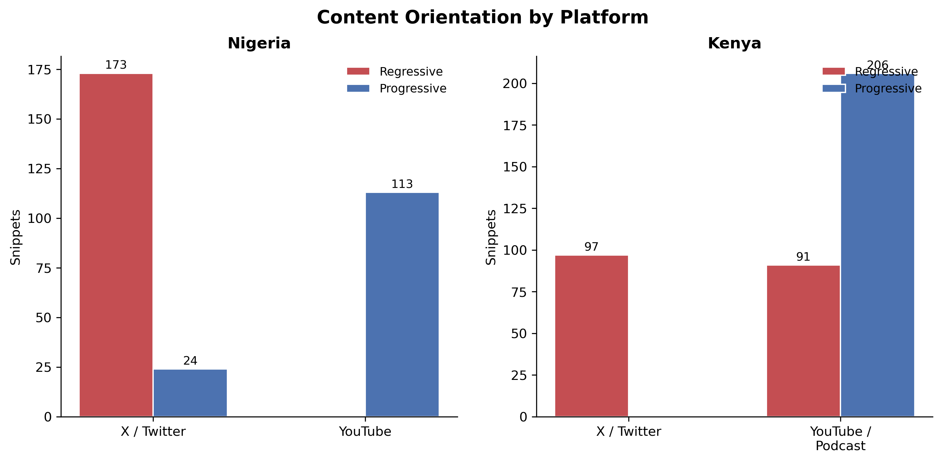
Figure 5. Content orientation by platform — Nigeria (left) and Kenya (right).

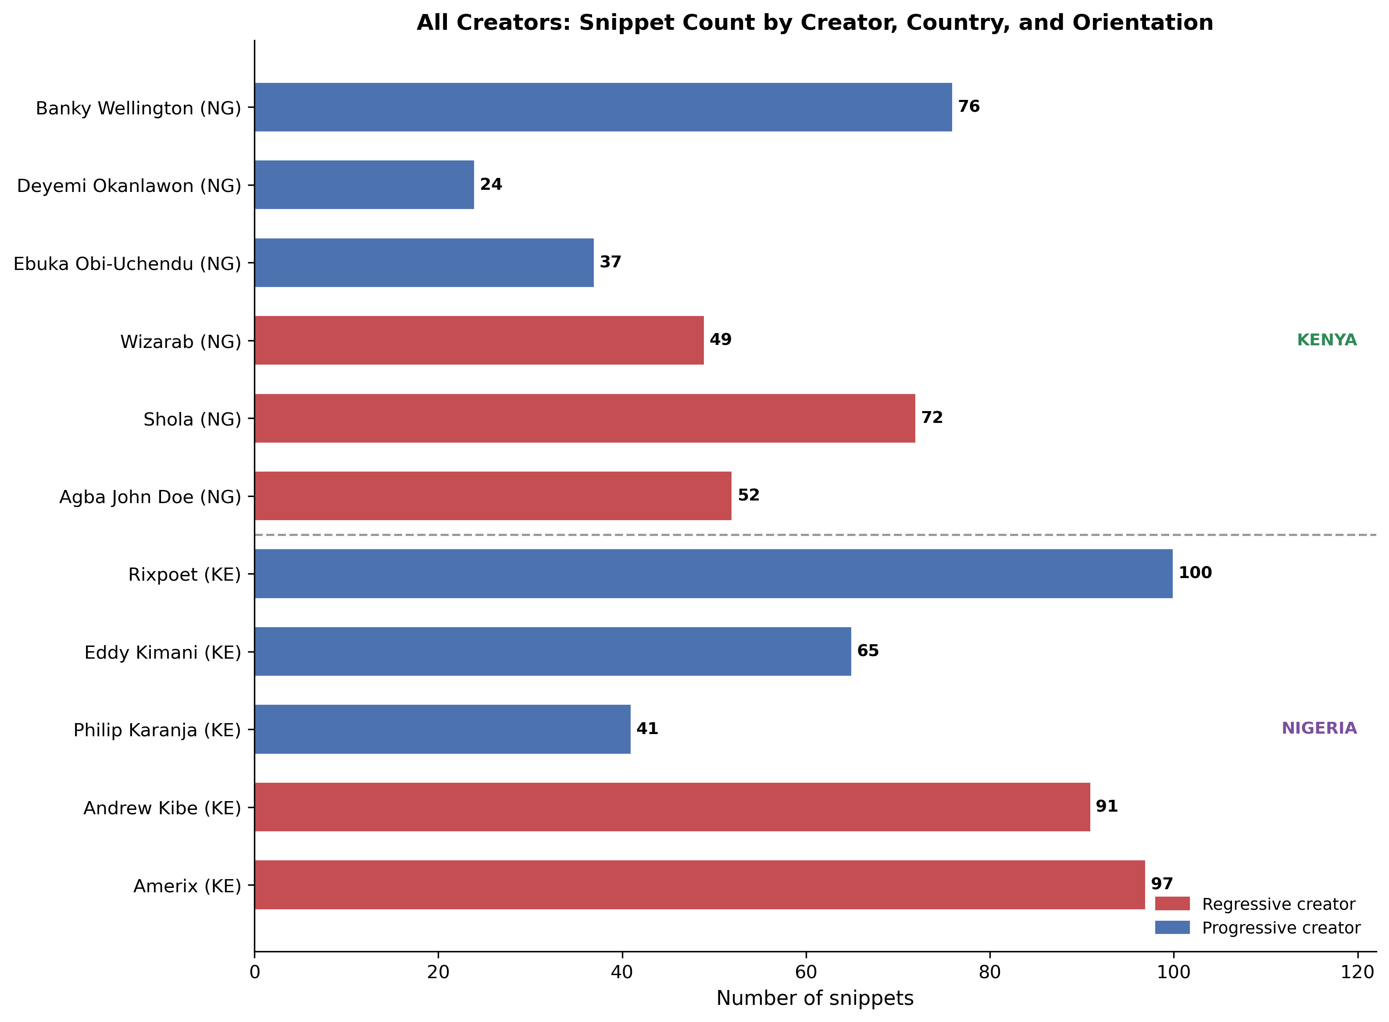
Figure 6. All creators: snippet count by creator, country, and orientation. Kenya appears above the divider; Nigeria appears below.

7. Discussion
The findings reported here allow several substantive claims about the landscape of digital masculinity discourse in Nigeria and Kenya, with implications for both the theoretical frameworks and the subsequent phases of the research project.
First, the data confirm the utility of the progressive/regressive analytical distinction while also revealing its limitations. Progressive creators do not simply oppose hegemonic masculinity; they often reproduce aspects of it while contesting others. Wellington’s critique of the provider burden does not extend to a critique of heteronormativity; Obi-Uchendu’s questioning of gentle parenting retains an investment in paternal authority. The progressive/regressive binary is a useful heuristic for sampling and initial analysis, but the coding phase will need instruments sensitive to the internal complexity of individual creators’ discourses.
Second, the data suggest that ambivalent sexism — Glick and Fiske’s (1996) distinction between hostile and benevolent sexism — is a productive analytical lens for the regressive content, but requires some adaptation. The Nigerian and Kenyan regressive creators produce content that combines hostile sexism (derogation, dominance assertion, moral disqualification of women) with what might be called pseudo-benevolent sexism: advice framed as helpful to men that is premised on the control or management of women. Amerix’s admonition that “if you are broke, zip up” reads as self-improvement advice but is also a form of population-level reproductive control ideology. The research team should attend to these hybrid forms in the coding phase.
Third, the trauma discourse in Kenya’s progressive content warrants specific analytical attention. Rixpoet’s neurobiological explanation of men’s violence represents an attempt to integrate structural and psychological accounts of harm that is unusual in popular men’s discourse globally. Whether this framing is analytically productive (because it contextualizes individual behavior) or potentially exculpatory (because it naturalizes male violence as a response to external conditions) is a question the data cannot resolve on their own. It is a question worth tracking across the coding phases, and potentially across the audience response data, which may reveal how audiences interpret and use this framing.
Finally, the community-building dimension of regressive content — evident in Agba’s “Agbafian” follower identity and Amerix’s “#ManDay” branding — suggests that ideological exposure is only part of the mechanism by which regressive masculinity content operates. The comment section is a community; following a creator is a form of identity affiliation; sharing a tweet is a form of social performance. The audience analysis (reported separately) will be essential for understanding how these community dynamics shape the normative effects of the content.

Appendix: Reach Metrics for Analyzed Content
All figures are as recorded in project scope documentation at the time of snippet selection, or retrieved from public platform data. “n/a” indicates the metric was not captured at collection time and is not recoverable from open sources (see footnotes). Repost counts for YouTube are not applicable.

Kenya — Post-Level Reach Metrics
Creator | Snippet | Platform | Views | Likes | Comments / Replies | Reposts / RT
Amerix | Stay away from vulgar women | X | n/a ¹ | 14,322 | 6,253 | 3,711
Amerix | A woman can’t love a man… | X | 662,079 | 13,592 | 464 | n/a
Amerix | She must surrender her independence to you | X | 444,333 | 10,248 | 375 | n/a
Amerix | Do not marry a modern woman | X | 281,103 | 7,781 | 213 | n/a
Amerix | Don’t marry women with >2 body counts | X | 649,494 | 8,276 | 429 | n/a
Andrew Kibe | Keep winning Gents — women are for good times | X | n/a ¹ | 992 | 63 | n/a
Andrew Kibe | As a man when you have nothing you are nothing! | X | n/a ¹ | 379 | 21 | n/a
Andrew Kibe | I wonder how some men are satisfied with one woman | X | 160,965 | 3,512 | 154 | n/a
Andrew Kibe | If Men Followed These 28 Rules | YouTube | 239,126 | 4,498 | 635 | n/a
Andrew Kibe | 28 Commandments — Wealth, Health & Respect | YouTube | 88,365 | 1,701 | 403 | n/a
Philip Karanja | Episode 1: A Girl Dad on a Mission | YouTube | 109,704 | 2,886 | 186 | n/a
Philip Karanja | Episode 2: 1 in 4 young women married as children | YouTube | 9,925 | 330 | 31 | n/a
Philip Karanja | Season Finale: Rape as Background Noise | YouTube | 12,338 | 443 | 59 | n/a
Philip Karanja | My Childhood Upbringing | TikTok | 55,702 | 1,004 | 66 | n/a
Philip Karanja | Episode 100: Pius Muchiri — role of a man | YouTube | 147,320 | 2,345 | 120 | n/a
Onyango Otieno | Undoing My Father’s Damage | YouTube | 50,619 | 916 | 174 | n/a
Onyango Otieno | My voice was beaten out of me by my father | YouTube | 36,394 | 676 | 251 | n/a
Onyango Otieno | Men, Addiction, and Violence | YouTube | 4,748 | 109 | 34 | n/a
Onyango Otieno | I Thought Having A Lot Of Sex Would Cure My Depression | YouTube | 12,391 | 206 | 17 | n/a
Onyango Otieno | Men’s Mental Health Workshop #NaRelate | YouTube | 86 | 7 | n/a ² | n/a
Eddy Kimani | Middle Class: We Grew Up Polished, Not Prepared! | TikTok | 75,800 | n/a ³ | 278 | n/a
Eddy Kimani | Rising From Failure | YouTube | 253,469 | 4,130 | 350 | n/a
Eddy Kimani | Not Done Yet | YouTube | 28,461 | 616 | 43 | n/a
Eddy Kimani | I Ruined My Marriage Out Of Depression | YouTube | 9,450 | 90 | 5 | n/a
Eddy Kimani | Men Lack Safe Space To Speak Out | YouTube | 2,069 | 20 | 3 | n/a
Eddy Kimani | Depression: Why it’s a challenge for men to reach out | YouTube | 1,833 | 22 | 4 | n/a

Nigeria — Banky Wellington: Post-Level Reach Metrics
Snippet | Platform | Views | Likes | Comments
Final Say Faith (feat. Adesua Wellington) | YouTube | 1,836,128 | 73,971 | 7,200
My Story — A Journey Through Hope & Faith | YouTube | 711,135 | 10,943 | 772
The Prison of Pornography — Road to Freedom Finale | YouTube | 53,240 | 788 | 81
Face it Like a Man | YouTube | 18,162 | 386 | 39
Faith after a Fall | YouTube | 27,386 | 1,413 | 141

Nigeria — Twitter/X Creators: Corpus-Level Engagement
Per-post metrics for Agba John Doe, Deyemi Okanlawon, Shola, and Wizarab were not consistently captured at collection time. Figures below represent aggregate engagement across each creator’s full corpus drawn from raw tweet files.
Creator | Posts in Corpus | Total Likes | Median Likes / Post | Total Retweets | Total Replies
Agba John Doe | 120 | 100,501 | 627 | 16,072 | 7,354
Deyemi Okanlawon | 135 | 13,209 | 23 | 1,623 | 862
Shola | 143 | 280,817 | 813 | 51,807 | 11,160
Wizarab | 100 | 25,157 | 94 | 5,676 | 3,959

¹ Pre-2022 X/Twitter posts: view counts were not surfaced publicly on the platform at the time of posting and are not recoverable from open sources.
² Video has fewer than 100 views; comment count not indexed by YouTube.
³ TikTok does not display like counts to external viewers on these videos. Metric not available.
Reach metric note: Some platform-level metrics could not be recovered from open web sources. For older X/Twitter posts (pre-December 2022), public view counts were not surfaced on the platform at the time of posting and are not recoverable from open sources; these are marked "n/a \u00b9". TikTok like and share counts require platform or API access and were not reliably visible through open web search; these are marked "n/a \u00b3". Repost/retweet counts for YouTube posts are not applicable to the platform. Where collection-time data from raw project files differed slightly from scope documentation, raw file values have been used as the primary source. Values left blank or marked "n/a" reflect genuine data unavailability, not estimation gaps.
^{n/a} Repost / RT counts not captured at collection time for YouTube and most X posts in this corpus.

7. Reach and Engagement Patterns
Interpretive note: The findings below are descriptive, not statistical or causal. They answer the question: which narratives and topics appear attached to higher-engagement posts in this sample? They do not establish that those narratives caused higher engagement. This is consistent with the exploratory scope of this analysis.
Note on cross-platform comparability: Engagement metrics are not directly comparable across platforms. Likes and retweets on X/Twitter reflect a different virality logic than YouTube comment counts or TikTok reply counts. Figures should be read within-platform.

7.1 Nigeria
On Nigeria X/Twitter, source-post metrics were not consistently captured for every sampled post, so the safest reach read is corpus-level rather than per-post average. In the raw tweet files, Shola shows the largest aggregate engagement among the Nigeria X/Twitter creators listed here, with 280,817 likes and 51,807 retweets across 143 posts, followed by Agba John Doe with 100,501 likes and 16,072 retweets across 120 posts, Wizarab with 25,157 likes and 5,676 retweets across 100 posts, and Deyemi Okanlawon with 13,209 likes and 1,623 retweets across 135 posts. These figures suggest strong engagement around sexual-marketplace/hypergamy, provider and relationship-economics narratives, and accountability/anti-rape narratives, but they should not be interpreted as causal evidence or directly comparable to YouTube/TikTok engagement.
The highest-engaging Nigeria posts centred on hypergamy and partner selectivity (Wizarab, Shola), provider masculinity and relationship economics (Agba John Doe), and counter-narratives around male accountability and anti-rape advocacy (Deyemi Okanlawon). Short, directive, provocative posts characteristic of regressive X/Twitter content attracted the highest retweet counts, consistent with the platform’s brevity-reward structure.

7.2 Kenya
On X/Twitter, Amerix (Eric Amunga, regressive) generated the highest raw reach in the Kenya sample. His post “Stay away from vulgar women” received 14,322 likes and 3,711 retweets — the single highest-reach post across both countries. Andrew Kibe (regressive, primarily active on YouTube/podcast) was also represented on X/Twitter, with sampled posts averaging 2,285 likes and 296 retweets. Both regressive creators’ highest-performing content centred on punitive femininity framing: female speech, self-presentation, and sexuality as grounds for relational disqualification.
Progressive creators operated primarily on YouTube and TikTok. Rixpoet’s YouTube videos averaged 204 comments per video, with highest engagement on father-son trauma and toxic masculinity content — generating sustained, emotionally disclosive comment threads consistent with the therapeutic resonance dynamic identified in the audience analysis. Eddy Kimani (TikTok/YouTube) and Philip Karanja (podcast/YouTube) operated in formats where reach metrics are structurally lower but audience engagement depth differs qualitatively from X/Twitter virality.

8. Technical Notes and Limitations
This analysis is explicitly exploratory and interpretive. The claims made here are grounded in verbatim evidence and theoretical frameworks, but they are not the product of systematic quantitative coding. They should be treated as hypotheses to be tested in the structured coding phases, not as findings to be reported as conclusions.
The corpus is not a random sample; it is a purposive sample designed to achieve balance across orientations and countries. The observed patterns — including the relative ideological depth of different creators and the cross-national differences in trauma discourse — may reflect the specific creators chosen as much as broader population-level differences in Nigerian and Kenyan digital masculinity discourse. Generalization beyond the sampled creators should be made with caution.
All content analysis involves interpretive choices. The decision to read certain content as “hostile sexism” rather than, say, “cultural tradition” or “self-help advice” reflects theoretical commitments that are made explicit here (Connell & Messerschmidt 2005; Glick & Fiske 1996) but are not the only possible analytical frames. The research team should be aware that creators’ self-understanding of their content — as advice, as advocacy, as education, as entertainment — may differ substantially from the analytical readings offered here.
No structured question-by-question coding was applied in producing this report. The findings are based entirely on close reading of verbatim text. The subsequent coding phases, using both human coders and LLM assistance, will provide systematic, comparable measures across creators and countries that will either confirm, qualify, or challenge the interpretive claims made here.

References
Connell, R. W., & Messerschmidt, J. W. (2005). Hegemonic masculinity: Rethinking the concept. Gender & Society, 19(6), 829–859.
Glick, P., & Fiske, S. T. (1996). The Ambivalent Sexism Inventory: Differentiating hostile and benevolent sexism. Journal of Personality and Social Psychology, 70(3), 491–512.

